FILE SYSTEM HIERARCHY
File System is a mechanism used in the O/S environment for storing the data in a systamatical order into a storage device.
UNIX/LINUX follows hierarchy file system standard (HFS) . In this file system all other directories mounted under the directory called root ( / ) .
/ --> Root (Top of the directory)
/root --> Super User (or) Administrator home directory, it represented by " ~ "(tilde) symbol .
Structure Of Linux
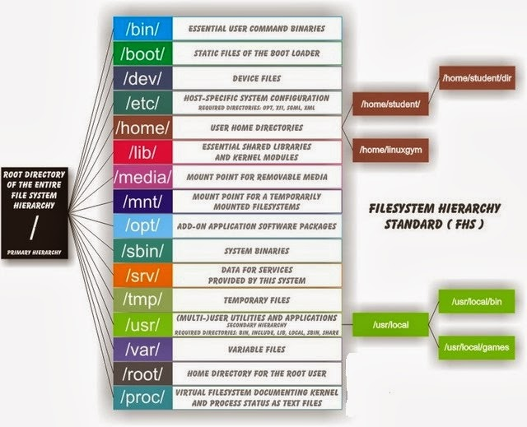
"/" this directory is called as root directory
It is the top of filesystem structure
All other directories are mounted under it.
(1) /root : this is default homedirectory of administrator
(2) /home : It contains all users home directories
(3) /boot : It contains bootable files like kernel (initrd image), bootloader (GRUB),
installer (ANACONDA-ks.cfg)
(4) /sbin : It contains administrative commands used by super user (root)
i.e. ADMINISTRATOR
(5) /bin : It contains commands used by superuser & normal user
(6) /usr : It contains the packages and application which are available for user
(similar to program files on windows)
(7) /var : It contains variable information such as logs and print queries
(8) /lib : It contains libraries need by no. of different application as well as linux kernel
(9) /etc : It contains all configuration files
(10) /proc : This directory contains current running process information.
(11) /tmp : This directory contains temporary files used by the system
(12) /opt : It contains the third party application
Eg : Core word effect, Sun star office
(13) /media : Removable media is stored under this directory.
(14) /dev : This directory contains devices modes through which the o/s can access
hardware (on software device on the system)
DEVICE IDE SATA
primary master /dev/hda /dev/sda
primary slave /dev/hdb /dev/sdb
secondary master /dev/hdc /dev/sdc
secondary slave /dev/hdd /dev/sdd

